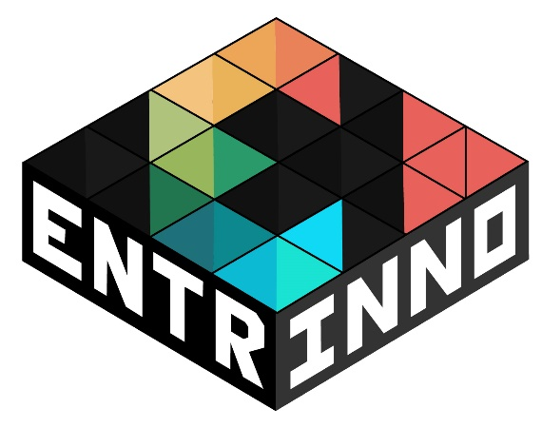
2nd Newsletter
February 2017
www.entrinno.org
Online Game for Innovation and Entrepreneurship

This newsletter provides information about different issues on entrepreneurship in the EU and updates on the EntrInnO project.

Entrepreneurship in the EU
Economic development in Europe relies significantly on people’s ability to practice entrepreneurial skills and therefore create new companies, with new opportunities for employment. The job market consists of many small and medium companies, many of which might encounter significant obstacles in their early stages. The challenge becomes imperative for supporting different skills related to entrepreneurship. The European Commission has expressed some issues, challenges, and actions, to address the topic.
The European Commission stresses that there are cultural factors which discourage too many people from starting a business and therefore there is a need to develop a more entrepreneurial culture, among EU citizens. In this context the Commission is working with Member States, in particular by facilitating the sharing of experiences and fostering entrepreneurial attitudes. Therefore, although for long there is an effort to infuse a culture of entrepreneurship and innovation through the emerging digital communications field, such progress remains fragmented, due to the limited motivation of EU citizens to use mainstream training mediums and absence of alternative learning environments, such as serious online games.
You can click here to read about promoting entrepreneurship on the European Commission’s website.

ENTREPRENEURSHIP SKILLS
Millions of users around the world are gaming regularly. Even though online gaming was primarily designed for entertainment and profit, quite recently it moved beyond private industry and turned into a research field in educational, training and learning disciplines. Gaming is based on interaction, collaboration, active and dynamic learning and an informal educational process that is invaluable. Such activities can help users to dynamically develop skills such as collaboration, networking experimentation, creativity, problem solving and decision making which constitute basic attributes of a progressive, entrepreneurial and market based economy and society.
As a general field, entrepreneurship encompasses several skills. Particular skills are through to be common and important for every entrepreneur. Such skills are also connected to lifelong learning, social participation, as well as general management. Collaboration, communication and successful networking are important for creating and maintaining good relationships in the entrepreneurship world.

LIFESTYLE ENTREPRENEURSHIP
Ever thought of turning you passion, hobby and interests into a business? It is possible, and of course, fun! To enable this a European project called ACE aims at promoting lifestyle entrepreneurship. The project includes two packages of materials: a) A package for adult educators, which aims at training trainers in delivering instruction and guide those who want to start their lifestyle business. b) A package for adult learners with information that enables and inspires them.

UPDATES FROM ENTRINNO
After multiple rounds of thinking and content development, partners are creating a game that can be used in both informal and academic settings. The gaming environment introduces the players into the world of entrepreneurship by assigning them with different tasks, providing videos and creativity challenges. Players are guided through a series of steps for creating and developing their ideas into a successful business. Contact us if you would like to be contacted when the final version of EntrInnO is released.

CONTACT US
Project website: www.entrinno.org
Email: info@entrinno.org
Facebook page: https://www.facebook.com/entrinno

